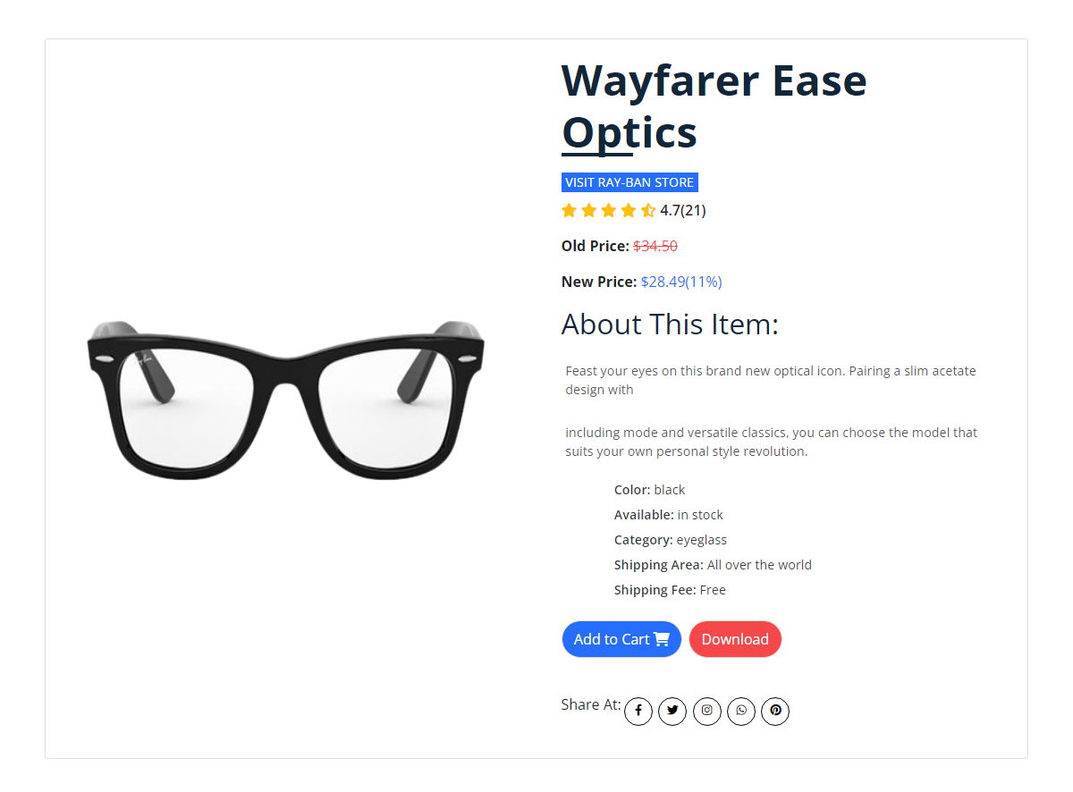
Go back to where it all began with Ray-Ban New Wayfarer eyeglasses. Using the same iconic shape as the classic Wayfarer, these eyeglasses offer an updated version that includes a smaller frame and slightly softer eye shape.
All Ray-Ban New Wayfarer eyeglasses are designed to offer an easy fit with a high level of comfort and style.
Product Details

